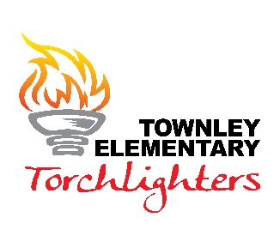
School-Parent Compact for the 2023-2024 School Year
Our Mission: At Townley, we ensure that all Torchlighters will learn and grow.
Our Vision: Torchlighters will shine brighter one day at a time.
We value: Relationships, Kindness & Gratitude, Empathy, Perseverance & Growth, Respectfulness, Responsibility, and A Positive Learning Environment
Parent/Guardian Commitment
I want my child to become a cooperative life-long learner who achieves at high levels and positively impacts our community. Therefore, I commit to do all the following:
- Communicate the importance of education and learning to my child.
- Ensure my child is on time and attends school each day.
- Read to my child or encourage my child to read every day.
- Regularly monitor my child’s progress in school and let my child’s teacher know when my child is struggling.
- Support my child by attending school functions, supporting school activities, and making every effort to attend parent/teacher conferences.
- Provide reinforcement by modeling the skills taught at school that develop respectful attitudes and behaviors.
Parent/Guardian Signature: ________________________________________________

Principal Commitment
I want all students to become cooperative life-long learners who achieve at high levels and positively impact our community. Therefore, I commit to do all the following:
- Communicate the school’s mission and goals to students and parents.
- Maintain and cultivate high standards of academic achievement and behavior.
- Maintain a welcoming environment for parents and students.
- Maintain a positive and safe learning environment.
- Provide appropriate staff development and training opportunities for teachers and parents on how they can build partnerships to support student achievement.
Principal Signature: _______________________________________________________________

Teacher Commitment
We want our students to become cooperative life-long learners who achieve at high levels and positively impact our community. Therefore, I commit to do all the following:
- Set high expectations for all students that promote the belief that failure is not an option.
- Remain competent and current in subjects taught and in instructional methods and strategies.
- Provide motivating and interesting learning experiences in my classroom.
- Welcome parents as volunteers.
- Communicate successes and concerns frequently with parents regarding student’s progress.
- Provide a safe and supportive environment and ensure all children are treated fairly with respect and compassion.
Teacher Signature: ______________________________________________________________

Student Commitment
It is important that I work to the best of my ability so I can become a cooperative life-long learner who achieves at high levels and positively impacts our community. Therefore, I commit to do all the following:
- Believe that I can and will learn and know that failure is not option.
- Set aside quiet time daily for reading.
- Share with my family about school.
- Ask my teacher questions when I don’t understand.
- Know and follow classroom and school expectations.
- Give my best effort, especially when I am learning something new.
- Be respectful of others and property.
- Be responsible for displaying appropriate behavior.
- Be ready to work, learn and be a positive example towards others, school, and learning.
Student Signature: _________________________________________________________________

Most importantly, we promise to help each other carry out this agreement.
Please sign and return to your child’s teacher.

